1. Install Power BI Desktop and share the final screenshot of the report view page which appears when power desktop starts.

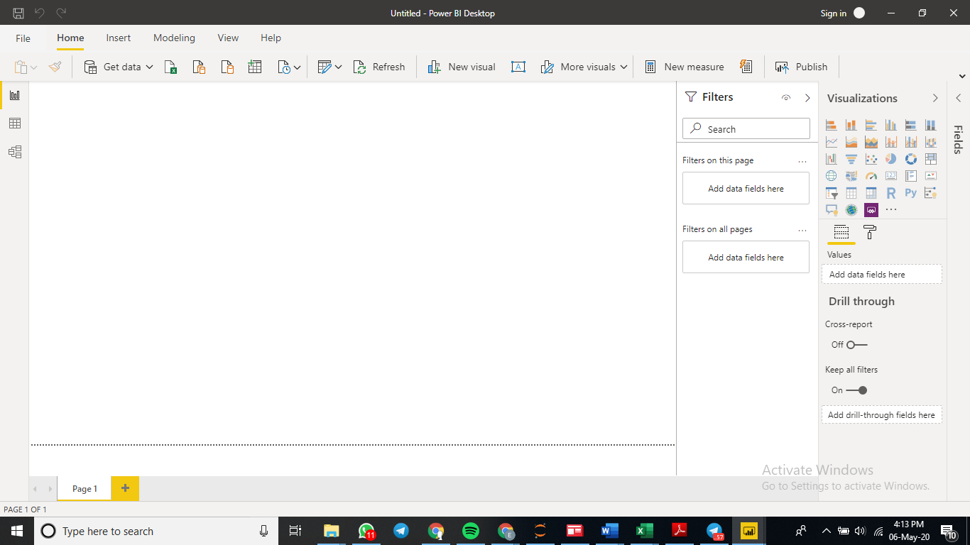

2. Prepare a document and with the following screenshot

− Report View

Report view is the import section of Power bi where the entire report is created. Report such as graph, tables, and kind od visualization. It has 3 sections fields, visualization and filter. Field section contains all the tables and their field. We can create new measures, table and manipulate them. Visualization section is used to create different types of graphs. Filters is used to apply filter.



− Data View

Data view is used to explore and understand the tables that we have loaded in the power bi. It is used to see the columns in the tables, and their data types. We can also add new column and perform DAX.

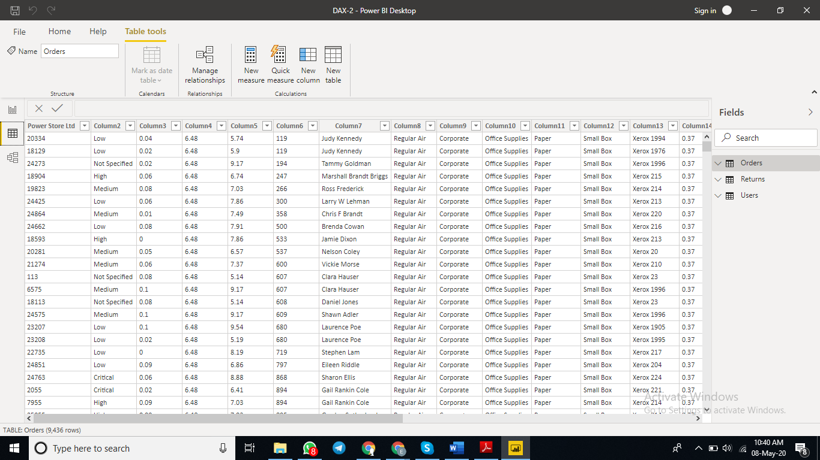

− Model View

Model view is used to view all the tables, columns and their relationship between the tables. Mainly it shows the schema of the entire data base. We can also create a relationship by edit option. Relationship is created between fact table and the reference table. Refence table is the table which shows details of the particular column in the fact table. Reference table has only Unique details.

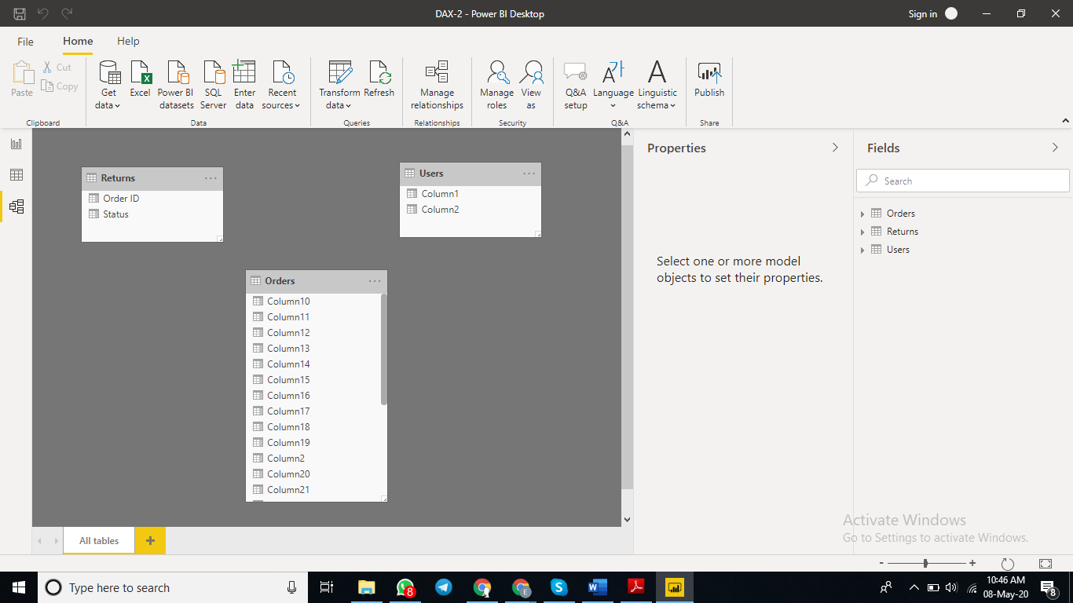

− Power Query Editor

Power query is seperate section in power bi where we can add connections with database, add columns, create a table, transform and load data

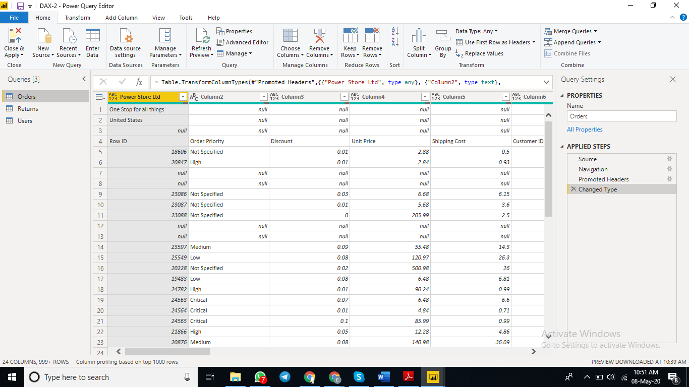

− Advance Editor

Advanced Editor is a feature in Power query editor, where we can use codes to edit the power query that is connecting, transforming, loading, creating table and adding columns.

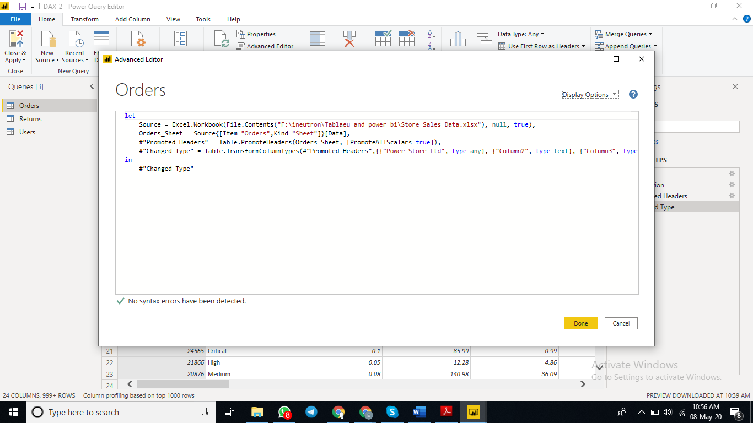

• Prepare a document with details of the following along with their price

− Power BI Desktop

Power BI Desktop is the free version of Power BI that you can install on your local computer as a program

Limitations:

* Can’t share created reports with non-Power BI Pro users
* No App Workspaces
* No API embedding
* No email subscriptions
* No peer-to-peer-sharing
* No support to analyze in Excel within Power BI Desktop

Price-Free

− Power BI Pro

Power BI Pro is the full version of Power BI

Advantages over desktop

* Ability to embed Power BI visuals into apps (PowerApps, SharePoint, Teams, etc)
* Native integration with other Microsoft solutions (Azure Data Services)
* Share datasets, dashboards and reports with other Power BI Pro users
* Can create App Workspaces and peer-to-peer sharing

Price- $9.99 monthly per user

− Power BI Premium

Power BI Premium is the most expensive tier of Power BI currently available and very distinct from the other two versions available on the market.

Advantages over pro

* Increased data capacity limits and maximum performance
* Access to one API surface
* Ability to embed Power BI visuals into apps (PowerApps, SharePoint, Teams, etc)
* Larger storage sizes for extended deployments
* Geo distribution, higher refresh rates, isolation, pin to memory, read-only replicas
* Power BI Report Server

Price-$4,995 monthly